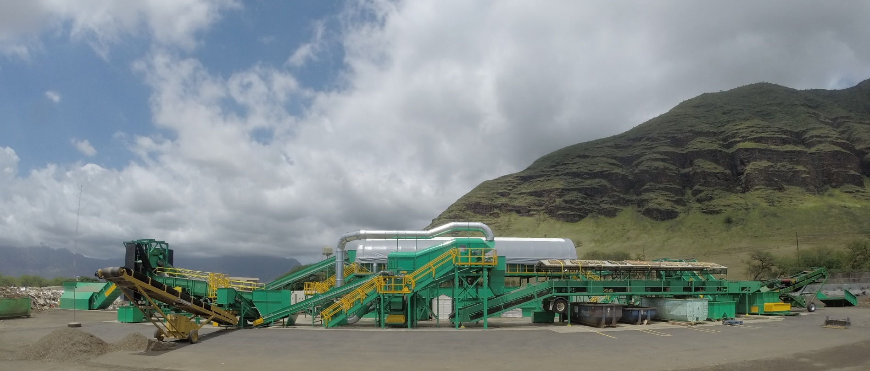
PVT Land Company Limited
87-2020 Farrington Highway,
Waianae, HI, 96792
www.pvtland.com

Lifeline Fire & Security - Exclusive security provider for PVT Land
PVT approached Lifeline looking for a new security provider that would be able to manage ALL of their video surveillance, intrusion alarm and access control systems instead of having multiple providers across multiple platforms.

Challenges
PVT land needed securing of their remote 650 acre facility on Waianae Coast. Their facility has some unique challenges including no power or data coverage in most areas, which makes communications and security in these areas very challenging.

Solution
Lifeline designed a multi-faceted integrated security and surveillance system. This scalable system included portable thermal solar powered video surveillance and high definition PTZ cameras with long-range night vision all connected using a high-capacity point-to-point wireless data network.

Results
PVT Land went looking for a security provider and found a business partner in Lifeline with innovative ideas to keep growing and enhancing their systems and security.

“We are more than happy with the results our new Lifeline security system has given us. The solutions Lifeline keeps coming up with for us are mind blowing!”
Steve Joseph – Vice President PVT Land Company
